**VISVESVARAYA TECHNOLOGICAL UNIVERSITY**



**“Jnana Sangama”, Belagavi-590018.**

**A Mini Project Report on**

**TIME TABLE GENERTOR**

**PHP PROGRAMMING[BAI358D]**

*Submitted in partial fulfillment of the requirements for the Degree of*

**BACHELOR OF ENGINEERING**

**IN**

**COMPUTER SCIENCE & ENGINEERING** **(DATA SCIENCE)**

**Submitted by,**

**JNANA JYOTHI.T.S**

**4AI22CD027**

**Under the Guidance of**

**Prof. Pallavi C S Asst. Professor**

**Dept. of Data Science**

**Dept. of Computer Science and Engineering (DATA SCIENCE) Adichunchanagiri Institute of Technology**

**Chikkamagaluru – 577102, Karnataka, India**[**2023-24**](http://www.aitckm.in/)

**ADICHUNCHANAGIRI INSTITUTE OF TECHNOLOGY**

*(Affiliated to VTU, Belagavi, Approved by AICTE, New Delhi and Accreditedby NAAC)*

**CHIKKAMAGALURU–577102, KARNATAKA, INDIA.**

***CERTIFICATE***

This is to certify that the report on **PHP Programming(BAI358D)** is prepared by **JNANA JYOTHI.T.S** Bearing USN **4AI22CD027** of 3rd semester B.E in partial fulfillment for the award of Bachelor of Engineering degree in **Computer Science and Engineering (DATA SCIENCE)** of the Visvesvaraya Technological University, Belagavi, during the year 2023-2024. Thereport is prepared according to the norms specified by the university. All the corrections suggested are incorporated. The report has been approved as it satisfies the academic requirements prescribed forthe said Degree and a copy of the same is deposited in the Library.

**Signature of the Guide Signature of the HOD**

# ACKNOWLEDGEMENT

I express my humble Pranamas to his holiness **Parama Poojya Jagadguru Padmabushana Sri Sri Sri Dr.Balagangadharanatha MahaSwamiji** and **Parama Poojya Jagadguru Sri SriSri Dr.NirmalanandanathaMahaSwamiji**and also to **Sri Sri Gunanatha Swamiji** Sringeri Branch Chikkamagaluru, for blessing us to achieve success and become noble citizens of our country.

I am deeply indebted to our honorable Director **Dr. C K Subbaraya**for creating therightkind ofcare andInfrastructure for us.

I am thankful to our beloved Principal **Dr. C T Jayadeva**for inspiring us to achievegreater endeavors in all aspects of Learning.

I express my deepest gratitude to **Dr.Adarsh M J,**Assoc.Professor & Head, **Dept. of Computer Science & Engineering (DATA SCIENCE)** for his valuable guidance, suggestions and constant encouragement in all our academic activities.

I would like to thank my guide **Mrs. Pallavi C S,** Asst. Professor, Dept. of Data Sciencefor her patience in our irregularities and timely correspondence with suggestions and corrections.

I would like to thank my beloved parents for their support, encouragement and blessings.

I express my gratitude to all the teaching and non teaching staff of Department of Computer Science & Engineering (DATA SCIENCE) and to all the persons who have helped me in preparing the report on Social connect and responsibility.

JNANA JYOTHI T S 4AI22CD027

# ABSTRACT

At Visvesvaraya Technological University (VTU), PHP programming stands as a cornerstone in the education of aspiring computer scientists and engineers. In the bustling classrooms and collaborative labs of VTU, students engage with PHP not merely as a language but as a gateway to dynamic web development. Through a curriculum finely tuned to balance theory with practice, studentsimmerse themselves in PHP's syntax and principles, all while grappling with the real-world challenges of database integration and server-side scripting. This handson approach, coupled with VTU's emphasis on teamwork and continuous learning, cultivates a breed of PHP programmers who are not just proficient in the language, but also adept at problem- solving and adaptable to the ever-evolving demands of the industry. Within VTU's ecosystem, PHP programming serves as more than just a subject—it's a conduit for honing skills vital for success in the digital age. By fostering an environment that encourages collaboration and innovation, VTU empowers its students to not only grasp the intricacies of PHP but also to explore its applications in diverse domains. From classroom projects to industry collaborations, VTU equips its students with the tools and mindset needed to navigate the dynamic landscape of web development with confidence and creativity

# CONTENTS

|  |  |  |
| --- | --- | --- |
| SL.NO | TITLE | PG.NO |
| 1.1 | Introduction | 1 |
| 1.2 | PHP code for simulation of timetable genertor | 2-5 |
| 1.3 | Output | 6-7 |
| 1.4 | Description | 8-9 |
| 1.5 | Conclusion | 10 |

## INTRODUCTION TO Hypertext Preprocessor [PHP]:

PHP, originally standing for **"Personal Home Page,"** now known as **"Hypertext Preprocessor,"**

PHP is a popular server-side scripting language that is widely used for web development. It is especially well-suited for creating dynamic web pages and web applications. PHP code is embedded within HTML, allowing developers to mix PHP and HTML code seamlessly.

Here are some key points about PHP:

* + - Open Source: PHP is open source, which means it is freely available for anyone to useand modify. This has contributed to its widespread adoption and the development of alargecommunity of PHP developers.
    - Easy to Learn: PHP is relatively easy to learn, especially for those with a backgroundin programming. Its syntax is similar to C, Java, and Perl, making it accessible to many developers.
    - Cross-Platform Compatibility: PHP code can run on various operating systems,including Windows, macOS, Linux, and Unix. This makes it a flexible choice for developing web applications that need to run on different platforms.
    - Database Integration: PHP provides built-in support for working with databases, particularly MySQL. It allows developers to easily connect to databases, execute queries, and fetch data, making it ideal for building database-driven web applications.
    - Support for Web Servers: PHP is compatible with most web servers used today, including Apache, Nginx, and Microsoft IIS. It can be seamlessly integrated with these servers to process PHP code and serve dynamic web content.
    - Rich Library Support: PHP has a vast ecosystem of libraries and frameworks that extendits functionality and simplify common web development tasks. Popular PHP frameworks include Laravel, Symfony, and CodeIgniter.
    - Security Features: PHP has built-in features for handling security issues, such as data validation, encryption, and protection against common security vulnerabilities like SQLinjection and cross-site scripting (XSS).

Overall, PHP is a versatile and powerful language for web development, offering a range of features and capabilities that make it a popular choice among developers for building dynamicandinteractive websites and web applications.

## A BASIC EXAMPLE Of HOW COULD SIMULATE AN TIMETABLE GENERTOR

**Introduction:**

To generate time tables for a PHP project, you'll need to break down the tasks involved, estimate their durations , dependencies, and assign resources accordingly. Here's a basicoutline of how you can approach this:

* + - **Task Identification:** List all the tasks required to complete the project. Break themdown into smaller, manageable units.
    - **Task Dependencies:** Determine which tasks are dependent on others. Some tasksmay need to be completed before others can start.
    - **Estimate Duration:** Estimate the time required to complete each task. Be realisticand consider factors like complexity, resources available, etc.
    - **Resource Allocation:** Assign resources (developers, designers, testers, etc.) to eachtask based on their skills and availability.
    - **Construct Gantt Chart:** Use a Gantt chart to visualize the project timeline .

Gantt

charts display tasks, durations, dependencies, and resource assignments in a timelineformat.

* + - **Iterative Planning:** Project plans are rarely perfect from the start. Be prepared to adjust your plan as the project progresses and new information becomes available.
* Here's a more detailed breakdown of what a timetable generator typically does:
* Input Parameters: Users provide input data such as:
* Duration of each activity/task.
* Dependencies between tasks (e.g., Task B cannot start until Task A is complete).
* Resource availability (optional).
* Constraints (e.g., specific time slots when certain tasks must occur).
  + - **Optimization Algorithm:** The timetable generator employs an algorithm to createan optimal schedule based on the input parameters provided. This algorithm mightaim to minimize the total duration of the schedule, balance resource utilization, or adhere to specified constraints.
    - **Schedule Generation:** The generator creates a timetable or schedule that outlines when each activity/task should occur. This schedule typically includes start and end times for each activity, as well as any relevant dependencies or constraints.
    - **Visualization:** The timetable generator may provide a visual representation of theschedule, such as a Gantt chart or calendar view. This allows users to easily

understand the timing and sequence of activity. The timetable generator may providea visual representation of the schedule, such as a Gantt chart or calendar view. This allows users to easily understand the timing and sequence of activity.

* + - **Adjustments and Iterations:** Users may have the option to adjust parameters or

constraints and regenerate the schedule as needed. This iterative process helps fine-tune the schedule to meet specific requirements or accommodate changes.

Timetable generators are commonly used in various domains, including project

management, school and university scheduling, event planning, employee shift scheduling, and transportation logistics. They help streamline the scheduling process, improve efficiency,and reduce the likelihood of conflicts or errors in scheduling.

## Code:

<!DOCTYPE html>

<html>

<head>

<title>Timetable Generator</title>

</head>

<body>

<h2>Timetable Generator</h2>

<form method="post" action="<?php echo $_SERVER['PHP_SELF']; ?>">

<label for="days">Enter the number of days in the timetable:</label>

<input type="number" name="days" id="days" min="1" required><br><br>

<label for="periods">Enter the number of periods per day:</label>

<input type="number" name="periods" id="periods" min="1" required><br><br>

<button type="submit" name="submit">Generate Timetable</button>

</form>

<?php

if ($_SERVER["REQUEST_METHOD"] == "POST" && isset($_POST['submit'])) {

$days = $_POST['days'];

$periods = $_POST['periods'];

// Display timetable form echo "<h3>Timetable</h3>";

echo "<form method='post' action='".$_SERVER['PHP_SELF']."'>"; echo "<table border='1'>";

echo "<tr><th>Day/Period</th>";

// Generate table headers for periods for ($p = 1; $p <= $periods; $p++) {

echo "<th>Period $p</th>";

}

echo "</tr>";

// Generate rows for each day

for ($d = 1; $d <= $days; $d++) { echo "<tr>";

echo "<td>Day $d</td>";

// Generate input fields for each period for ($p = 1; $p <= $periods; $p++) {

echo "<td><input type='text' name='subject[$d][$p]'></td>";

}

echo "</tr>";

}

echo "</table><br>";

echo "<button type='submit' name='save'>Save Timetable</button>"; echo "</form>";

} ````````````

// Display saved timetable

if ($_SERVER["REQUEST_METHOD"] == "POST" && isset($_POST['save'])) {

$subjects = $_POST['subject'];

echo "<h3>Saved Timetable</h3>"; echo "<table border='1'>";

echo "<tr><th>Day/Period</th>";

// Generate table headers for periods for ($p = 1; $p <= $periods; $p++) {

echo "<th>Period $p</th>";

}

echo "</tr>";

// Display saved subjects

foreach ($subjects as $day => $periods) { echo "<tr>";

echo "<td>Day $day</td>"; foreach ($periods as $subject) {

echo "<td>$subject</td>";

}

echo "</tr>";

}

echo "</table>";

}

?>

</body>

</html>

* 1. **Output:**

Step 1:

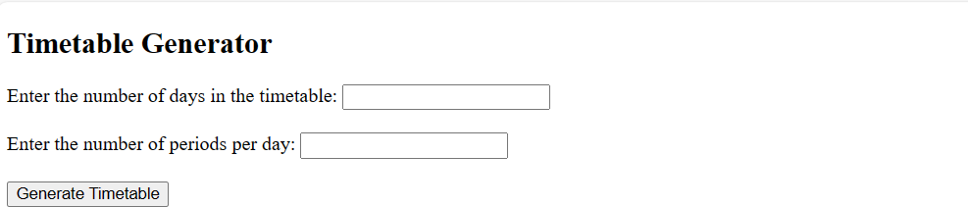

* + - Number of days in the timetable.
    - Number of periods per day.

Once you provide that information, I'll assist you in generating the timetable. Additionally, ifyou have any specific requirements or preferences, feel free to mention them.

Step 2:

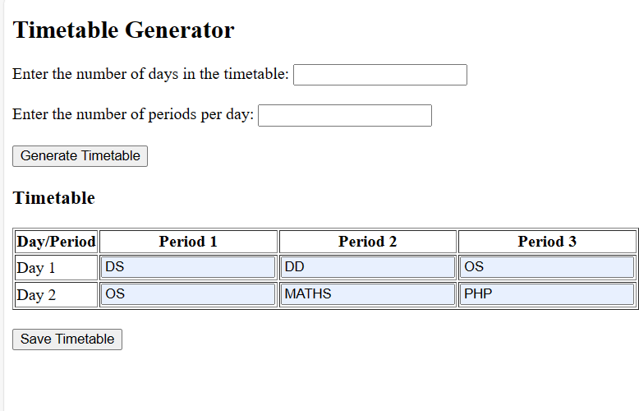

Timetable

|  |  |  |  |
| --- | --- | --- | --- |
| Day/Period | Period 1 | Period 2 | Period 3 |
| Day 1 | DS | DD | OS |
| Day 2 | OS | MATHS | PHP |

This timetable consists of 2 days and 3 periods per day. Each cell represents a subject abbreviation. If you want to save this description, you can copy and paste it into a textdocument or any other preferred format.

Step 3:

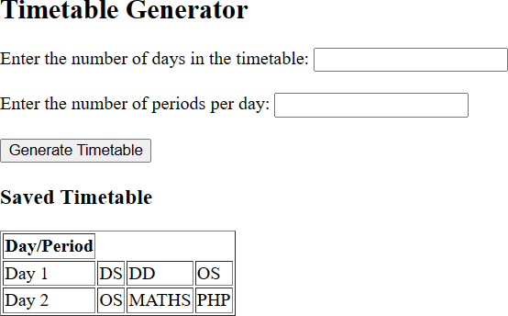

|  |  |  |  |
| --- | --- | --- | --- |
| Day/Period |  | | |
| Day 1 | DS | DD | OS |
| Day 2 | OS | MATH  S | PHP |

* Number of days in the timetable.
* Number of periods per day.

Day 1:

Period 1: Data Structures (DS)Period 2: Digital Design (DD)

Period 3: Operating Systems (OS)Day 2:

Period 1: Operating Systems (OS)Period 2: Mathematics (MATHS) Period 3: PHP

This timetable spans over 2 days with 3 periods per day. Each period is assigned a specificsubject.

# DESCRIPTION:

A timetable generator is a software tool designed to automatically create schedules or timetables for various purposes. Whether it's organizing classes in a school, planning shiftsfor employees, scheduling appointments, or managing project tasks, a timetable generator

simplifies the process by efficiently allocating resources and time slots to different activities.Here's a detailed description of how a typical timetable generator works.

* + - **Input Parameters:** Users input various parameters necessary for scheduling. Theseparameters can include:
      * Activities or tasks to be scheduled.
      * Duration estimates for each activity.
      * Dependencies between activities (e.g., Activity B can only start after Activity A iscompleted).
      * Resource availability, such as personnel or equipment.
      * Constraints or preferences, such as preferred time slots for certain activities.
    - **Algorithm Selection:** Depending on the complexity of the scheduling problem and the specific requirements, the timetable generator employs different algorithms or techniques to create an optimized schedule. These algorithms can range from simpleheuristic approaches to more sophisticated optimization algorithms like genetic

algorithms or linear programming.

* + - **Optimization Process:** The timetable generator processes the input data andattempts to create an optimal schedule based on predefined criteria. This

optimization process aims to achieve objectives such as:

* + - * Minimizing the total duration of the schedule.
      * Balancing resource utilization.
      * Avoiding conflicts or overlaps between activities.
      * Adhering to constraints and preferences specified by the user.
    - **Schedule Generation:** Once the optimization process is complete, the timetable

generator generates a schedule that outlines the timing and sequence of activities.This schedule typically includes details such as:

* + - * Start and end times for each activity.
      * Assignments of resources to activities.
      * Visualization of the schedule in various formats, such as Gantt charts, calendar views,or tabular representations.
    - **Review and Adjustment:** Users have the option to review the generated schedule and make adjustments as needed. They can modify input parameters, add or removeconstraints, or manually override certain scheduling decisions based on specific

requirements or preferences.

* + - **Iterative Improvement:** In some cases, the timetable generator supports an iterativeprocess where users can refine the schedule over time based on feedback or changesin requirements. This iterative improvement helps ensure that the schedule remains optimal and up-to-date.

Overall, a timetable generator streamlines the scheduling process, saves time, and improvesefficiency by automating the complex task of creating schedules while considering various constraints and objectives. It enables users to focus on higher- level decision-making and strategic planning rather than getting bogged down in the details of scheduling.

# CONCLUSION:

The timetable generator is a tool designed to create structured schedules for organizing activities, classes, or events over a specified duration. It allows users to input parameters suchas the number of days and periods per day, and then generates a timetable according to

these specification.

Key features and components of a timetable generator typically include:

Input Parameters: Users provide details such as the number of days in the timetable and thenumber of periods per day.

Generation Algorithm: The generator utilizes algorithms to distribute subjects or activitiesevenly across the timetable, considering constraints such as class availability, teacher

schedules, and any specified preferences.

Output Display: The generated timetable is presented in a structured format, often as a gridwith days and periods, along with the assigned subjects or activities for each slot.

Customization Options: Some timetable generators may offer customization options, allowing users to prioritize certain subjects, designate break times, or

accommodate specialrequirement.

Description or Summary: A summary or description of the generated timetable may be provided, highlighting the subjects or activities assigned to each period and

providing anoverview of the schedule.

Overall, a timetable generator streamlines the process of creating schedules, whether foreducational institutions, businesses, or personal planning purposes, by automating the

organization of activities within specified timeframes.